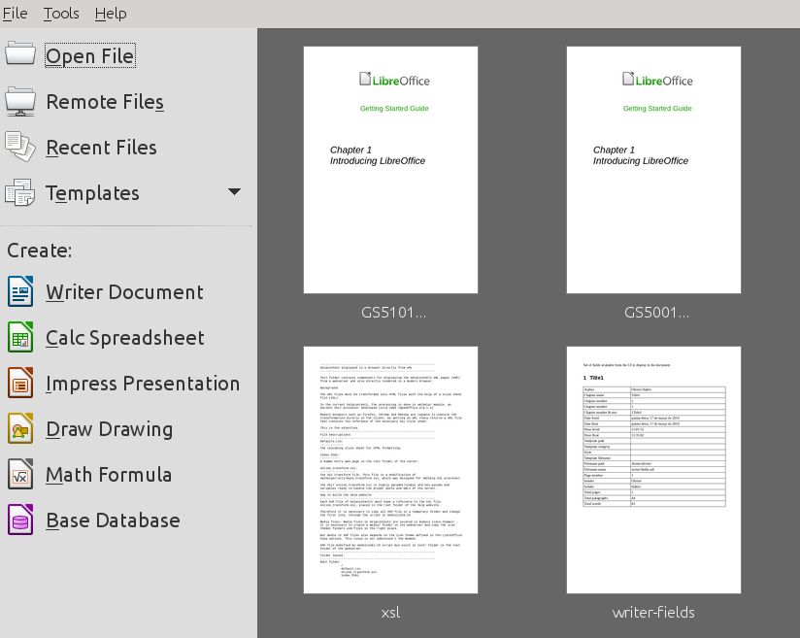
Illustration 1: This is image 1
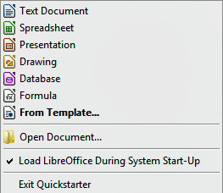
If you do not have Microsoft Office installed on your computer, or if Microsoft Office is installed but you have associated Microsoft Office file types with LibreOffice, then when you double-click on the following files, they open in LibreOffice:
- A Word file (*.doc or *.docx) opens in Writer.
- An Excel file (*.xls or *.xlsx) opens in Calc.
- A PowerPoint file (*.ppt or *.pptx) opens in Impress.
If you did not associate the file types and Microsoft Office is installed on your computer, then when you double-click on a Microsoft Office file, it opens using the appropriate Microsoft Office component.

Put cursor before frame of first picture and give an enter...

